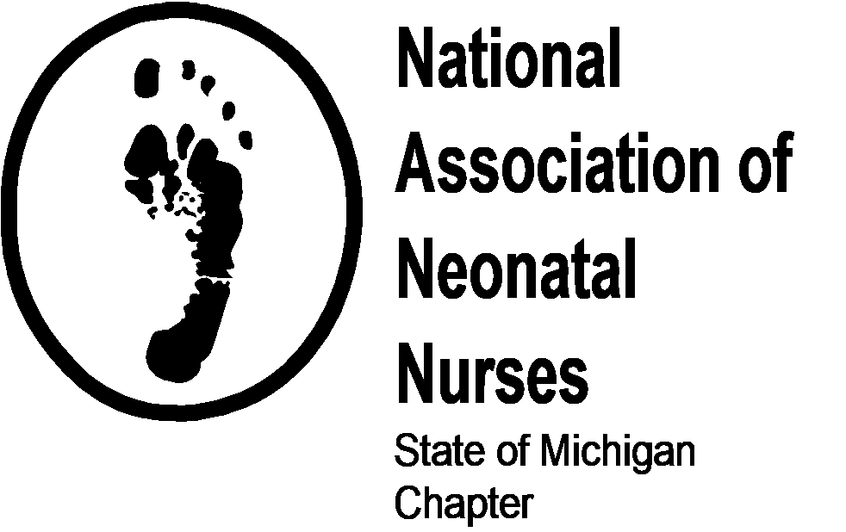

Nursing Scholarship Application

We are offering multiple nursing scholarships in the amount of $500 each.

ELIGIBILITY:

All applicants must meet the following criteria:
- Current enrollment in an accredited Baccalaureate nursing degree program
- Be a permanent resident of the State of Michigan
- Have a cumulative GPA of 3.0
- Have an interest in pursuing neonatal/maternal child health nursing after graduation
- Candidates are asked to receive scholarship in person at our January Business Meeting

INSTRUCTIONS:

- Fill out the attached form completely and accurately. Please type or print.
- Use an additional page for personal statement.
- Please include at least three letters of recommendation from academic or clinical instructors.
- Applications must be emailed or postmarked by December 31, 2021. Incomplete or late applications will not be considered.
- Submit the completed application and supplemental documents to:

SMANN Scholarship Program
Ashley Burnham, SMANN President
3910 Basswood Dr SW
Grandville, MI 49418
Or email it back to smannpresident@gmail.com (preferred)

1. GENERAL INFORMATION

Last Name First Name MI

Street Address Apt #

City State Zip Code

Daytime Phone Number Email Address

( )

All applicants must be citizens of the United States or have Permanent Visa Status.

U. S. Citizen: Yes No Eligible Non-Citizen# ________________________

Please attach a photocopy of your Michigan driver’s license or state ID card.

2. SCHOOL INFORMATION

School Name

City State

Nursing Major GPA Expected Graduation Date

Enrollment Status (circle one) Semester Currently Enrolled

Part-Time Full-Time Sophomore Junior Senior

All students:
Have you ever been on, or are you currently on academic probation?

Yes No

If yes, please give details:
RN to BSN graduates only:
If you are an RN, have you ever had, or do you currently have any stipulation against your license?

Yes No

If yes, please give details:

Other colleges/universities attended:

Dates Attended | School | Degree Obtained

3. EMPLOYMENT

Are you currently employed? Yes No

If yes, what is the average number of hours worked per week: _______________

Employment history:

Dates | Employer | City/State | Role

4. SCHOLARHIPS, AWARDS, GRANTS

Please list any other scholarships, awards or grants that you have received:

Date | Source | Amount | Status

5. OTHER HONORS, AWARDS

Please list any other awards, honors, memberships of professional organizations, leadership roles, etc…

Date | Award/Honor/Membership/Role | Source/Organization

6. PROFESSIONAL GOALS AND CAREER INTERESTS

On a separate piece of paper, please discuss why you feel you qualify for this scholarship. Your statement must be typewritten and no more than 500 words. It should address the following topics:
- What led you to a career in nursing?
- Why are you interested in neonatal/maternal child health nursing?
- What are your professional goals?
- What challenges to you feel that you had to overcome to get where you are today?

7. LETTERS OF RECOMMENDATION

Please include three letters of recommendation with at least one from an academic or clinical instructors.

8. CERTIFICATION

I acknowledge that all the information on this application is true and complete to the best of my knowledge.

I will use the proceeds of this scholarship for the payment of tuition and fees, books and professional materials and equipment associated with my studies in the school of nursing.

I consent to the release of the included information only to the members of the State of Michigan Association of Neonatal Nurses for the purpose of evaluating my eligibility for this scholarship.

______________________________________ ____________________
Signature of Applicant Date

